- Alongside our new baseline forecast, we've published two alternative scenarios for oil and gas prices. In a worst-case scenario where oil rises to $140 per barrel, we find that UK inflation would likely top 5% in Q4 2026. This could cause the Bank of England to hike interest rates again, and the UK would likely suffer a mild recession.
- Even before the conflict began, the UK economy was struggling to gain momentum, with GDP flat in January. Residual seasonality in the data should mean that quarterly growth in Q1 2026 is stronger than the outturns seen in H2 2025, but the pickup is likely to be much smaller than that seen at the start of last year.
The second week of the conflict between US-Israel and Iran has seen further extreme volatility in oil and gas prices. Odds are volatility will continue given the absence of a timeline for when the conflict will deescalate and when the Strait of Hormuz, which is effectively closed, will see traffic begin to recover.
We published our March baseline forecast this week. This assumed that oil prices fall back to average around $80 per barrel in Q2, then gradually converge on our pre-conflict forecast. This hinges on the assumption that there is roughly half the usual traffic through the Strait of Hormuz for two months. But with traffic currently significantly lower, this points to upside risk to the oil forecast.
Given the significant uncertainty around how the conflict will evolve, we've published two alternative scenarios. The first assumes oil and European gas prices rise more than we anticipate in Q2, with oil averaging $100 per barrel. The second sees oil hitting $140 a barrel along with a bigger spike in gas prices. Simulations run on our Global Economic Model suggest $140 is the economic breaking point for the global economy, and our worst-case scenario assumes the oil price remains at this level for roughly two months.
In both scenarios, the main transmission channel to the economy is through higher inflation (Chart 1). Daily data from RAC suggests petrol prices have already risen sharply over the past two weeks. Domestic energy bills would also rise substantially in July, when the next change in the energy price cap comes into force.
Chart 1: Oil prices of $140 would likely tip the UK economy into a mild recession
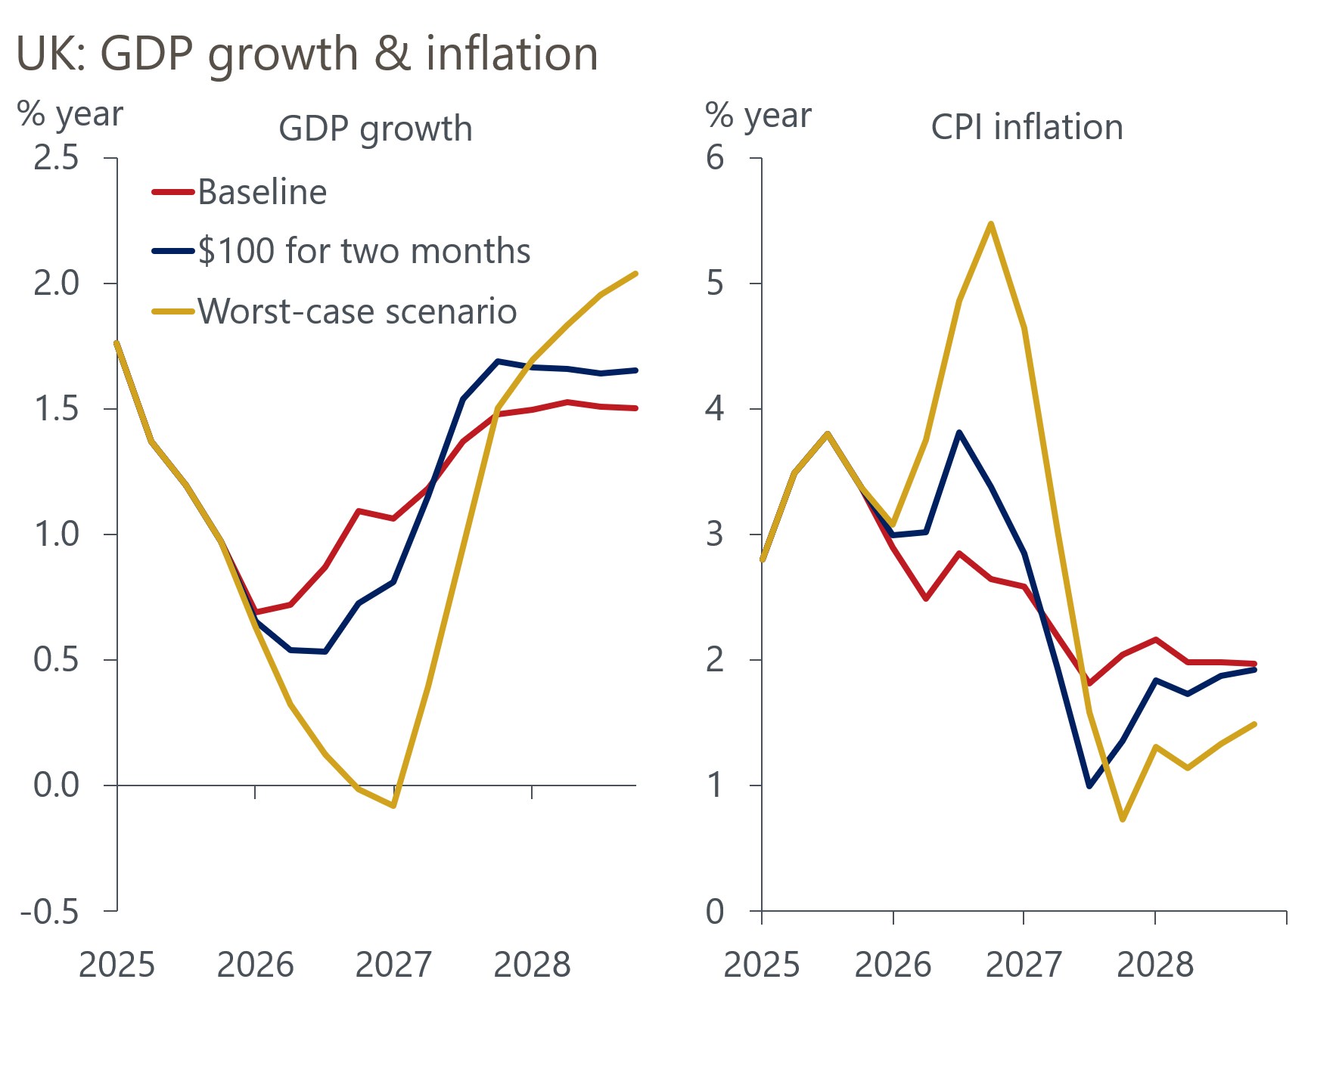
Sources: Oxford Economics, Haver Analytics

Our simulations suggest that CPI inflation could rise as high as 3.8% in Q4 in the $100 oil scenario and 5.5% in the worst-case scenario.
As we argued in a recent note, central banks can’t look through the inflationary effects of energy price shocks in the way they have before. Given the Monetary Policy Committee's concerns about the risk of a renewed rise in inflation expectations, such a pickup in inflation would likely result in Bank Rate being held at 3.75% for a prolonged period. Indeed, in the worst-case scenario, we think the MPC might tighten policy modestly, particularly if the government tries to mitigate the impact of higher energy bills with a near-term loosening of fiscal policy.
The combination of tighter financial conditions and higher inflation squeezing household finances would damage growth prospects. In our more benign scenario, GDP growth in 2026 would be around 0.2ppts below our baseline forecast of 0.8%. In a worst-case scenario, the hit would be greater and the UK would likely suffer a mild recession.
We will continue to monitor the Middle East situation and financial market developments. These scenarios provide a guide to how our baseline forecast may evolve if oil prices rise further.
The week's only major data release suggested that the economy was struggling to generate momentum even before the Middle East conflict began. GDP was flat in January. Though distribution output rose strongly, in line with January's big rise in retail sales, there were large falls in output in several services sub-sectors, after output had spiked in December.
The momentum provided by back-to-back monthly increases in GDP at the end of last year provides a decent launchpad for Q1. Evidence of ongoing residual seasonality in the output data also points to quarterly growth in Q1 coming in higher than the outturns seen in H2 2025. But the momentum in early-2026 is weaker than it was at this point last year (Chart 2).
Chart 2: The momentum at the start of 2026 is weaker than in recent years
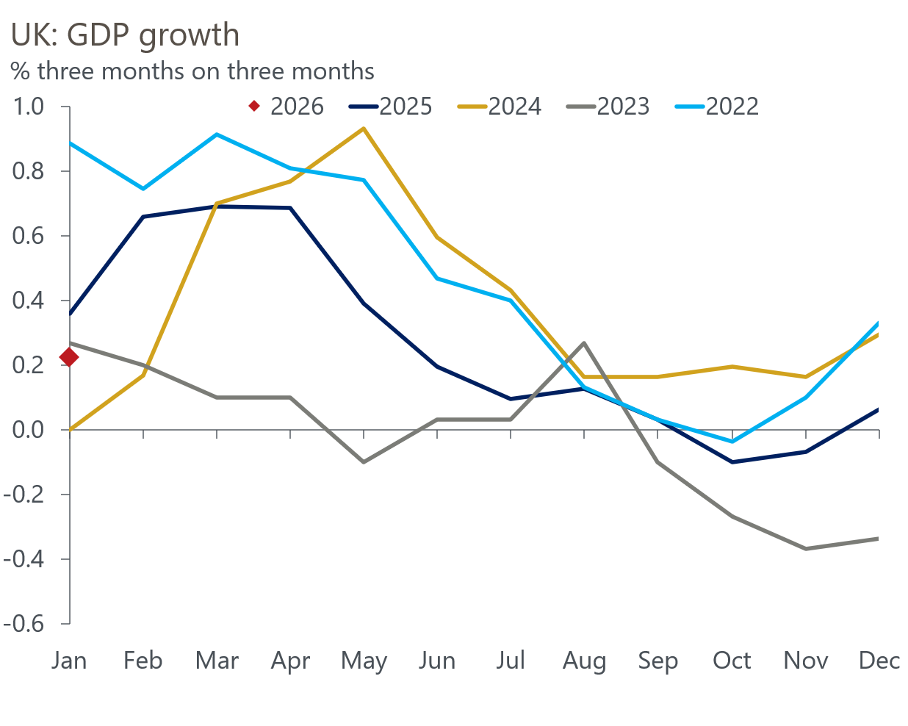
Source: Haver Analytics
We've long bemoaned the absence of a sustainable growth driver. With the Middle East conflict adding to the challenges facing the private sector, the reliance on the public sector to drive GDP growth this year has increased. The longer that oil and gas prices stay high, the more pressure will build on the Chancellor to offer fiscal support.

The week ahead
Next week's main event is March's meeting of the Bank of England's Monetary Policy Committee. Until the Middle East conflict began, there was a good chance that the MPC would vote to cut rates next week. But we now think that outcome is very unlikely, with uncertainty around the inflationary implications of the spikes in oil and gas prices taking a cut off the table. We expect the vote to hold Bank Rate at 3.75% to be at least 7-2, but it's conceivable that all nine members vote to hold given the degree of uncertainty.
On the morning of the MPC announcement, the Office for National Statistics will publish its latest labour market release. Though December saw headline (three-month average of the annual rate) pay growth drop, this was entirely due to base effects and month-on-month growth was surprisingly strong. With the base effects now fading, we expect only a modest cooling in headline pay growth in January, with total pay growth set to come in at 4.1% and regular pay at 4%.
On the quantities side, October's quirky large increases in both employment and unemployment will drop out of the three-month averages. We think the unemployment rate will hold steady at 5.2%, but the risks are skewed towards a higher outturn.
Table 1: Week ahead calendar
Date | Events | Period | Measure | Unit | Previous | Forecast
Mar 19 | LFS unemployment | Nov-Jan | Rate | % | 5.2 | 5.2
Mar 19 | Average earnings (total pay) | Jan | 3m, y/y | % | 4.2 | 4.1
Mar 19 | Average earnings (regular pay) | Jan | 3m, y/y | % | 4.2 | 4.0
Mar 19 | BoE Bank Rate decision | Mar | Bank Rate | % | 3.75 | 3.75
Mar 20 | Public finances | Feb | PSNB | £bn | -30.4 | 7.0
Source: Oxford Economics

Key forecasts
Table 2: UK forecast overview
(Annual percentage changes unless specified)
 | 2023 | 2024 | 2025 | 2026 | 2027 | 2028
GDP | 0.3 | 1.1 | 1.3 | 0.8 | 1.3 | 1.5
Private consumption | -0.3 | -0.1 | 1.0 | 0.8 | 1.0 | 1.4
Fixed investment | 0.5 | 1.7 | 3.4 | 1.4 | 2.0 | 2.0
Government consumption | 2.1 | 2.9 | 1.7 | 2.1 | 1.6 | 1.4
Exports of goods and services | -2.3 | 1.4 | 1.6 | 0.8 | 1.0 | 1.5
Imports of goods and services | -1.6 | 2.7 | 4.2 | 0.0 | 1.1 | 1.6
Industrial production | -2.6 | -1.3 | 0.3 | 0.7 | 0.9 | 1.2
Consumer prices | 7.3 | 2.5 | 3.4 | 2.7 | 2.2 | 2.0
Unemployment rate (%) | 4.1 | 4.3 | 4.9 | 5.3 | 5.1 | 4.8
Current a/c balance (% of GDP) | -3.6 | -3.0 | -2.8 | -3.4 | -3.0 | -2.9
Government balance (% of GDP) | 5.2 | 5.3 | 5.1 | 3.5 | 3.2 | 2.8
Central bank policy rate (%, EOP) | 5.25 | 4.75 | 3.75 | 3.25 | 3.00 | 2.75
10yr govt. bond yield (%, EOP) | 3.54 | 4.57 | 4.47 | 4.38 | 3.95 | 3.60
Exchange rate (US$ per £, EOP) | 1.27 | 1.25 | 1.35 | 1.30 | 1.30 | 1.30
Exchange rate (euro per £, EOP) | 1.15 | 1.21 | 1.15 | 1.11 | 1.10 | 1.10
Source: Oxford Economics
Table 3: Quarterly forecasts for the UK
 | 2025 |  |  |  | 2026
 | Q1 | Q2 | Q3 | Q4 | Q1 | Q2 | Q3 | Q4
GDP (% year) | 1.8 | 1.4 | 1.2 | 1.0 | 0.7 | 0.7 | 0.9 | 1.1
CPI inflation (% year) | 2.8 | 3.5 | 3.8 | 3.4 | 2.9 | 2.5 | 2.9 | 2.6
Bank Rate (%, EOP) | 4.50 | 4.25 | 4.00 | 3.75 | 3.75 | 3.50 | 3.50 | 3.25
10yr gilt yield (%, EOP) | 4.70 | 4.48 | 4.70 | 4.47 | 4.50 | 4.48 | 4.45 | 4.38
US$ per £ (EOP) | 1.29 | 1.37 | 1.35 | 1.35 | 1.33 | 1.32 | 1.31 | 1.30
Euro per £ (EOP) | 1.20 | 1.17 | 1.15 | 1.15 | 1.15 | 1.13 | 1.12 | 1.11
Source: Oxford Economics

Latest Country Economic Forecast:
February 16, 2026

Recent publications

Data Insights
GDP was flat in January, and underlying conditions look soft
Middle East conflict likely to halt run of strong PMI readings
Recent rise in Manufacturing PMI is too optimistic
Mortgage activity remained weak at the start of 2026
February's PMI suggests economic momentum remains strong

Research Briefings
MPC preview – Middle East war takes March cut off the table
How will central banks respond to the Iran conflict?
OBR forecasts were out of date before they were published
Productivity may be picking up – but not in a good way
The 2026 inflation outlook is a tale of two halves

Contacts

Oxford Economics' UK team
- Andrew Goodwin - Chief UK Economist - agoodwin@oxfordeconomics.com
- Edward Allenby - Senior UK Economist - eallenby@oxfordeconomics.com

